[E117] Internal temperature sensor

If you see a permanent negative value, zero or 85 °C on the screen, first you have to check if the plug of the temperature sensor is plugged properly into the MCU.

Make sure that both end of the temperature sensor cable is connected properly.

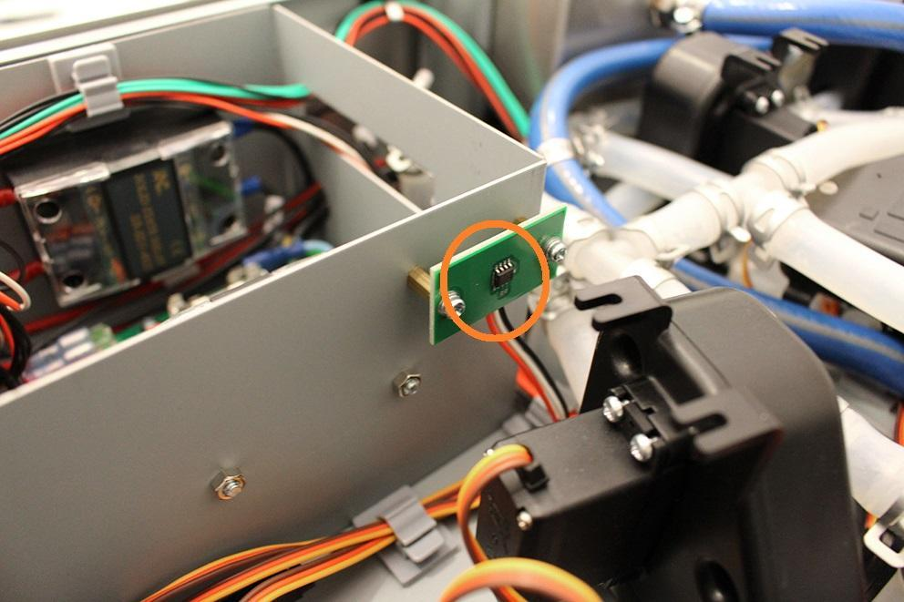

The plug of the temperature sensor cable at the MCU side.

